Chapter 2, Problem 35.

Calculate V_{o} and I_{o} in the circuit of Fig. 2.99.

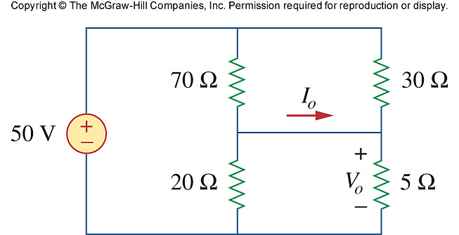
200 V

Figure 2.99
For Prob. 2.35.

